**Exercise 1: Configuring a Basic Spring Application**

**Pom.xml :**

<project xmlns="http://maven.apache.org/POM/4.0.0"

xmlns:xsi="http://www.w3.org/2001/XMLSchema-instance"

xsi:schemaLocation="http://maven.apache.org/POM/4.0.0

http://maven.apache.org/xsd/maven-4.0.0.xsd">

<modelVersion>4.0.0</modelVersion>

<groupId>com.library</groupId>

<artifactId>LibraryManagement</artifactId>

<version>1.0-SNAPSHOT</version>

<dependencies>

<dependency>

<groupId>org.springframework</groupId>

<artifactId>spring-context</artifactId>

<version>5.3.34</version>

</dependency>

</dependencies>

</project> **BookService.java:**

package com.library.service;

import com.library.repository.BookRepository;

public class BookService {

private BookRepository bookRepository;

// Setter for Spring DI

public void setBookRepository(BookRepository bookRepository) {

this.bookRepository = bookRepository;

}

public void addBook(String title) {

System.out.println("Service: Adding book - " + title);

bookRepository.saveBook(title);

}

}

**BookRepository.java:**  
  
package com.library.repository;

public class BookRepository {

public void saveBook(String title) {

System.out.println("Repository: Book '" + title + "' saved to database.");

}

}  
**Main.java:**  
package com.library;

import com.library.service.BookService;

import org.springframework.context.ApplicationContext;

import org.springframework.context.support.ClassPathXmlApplicationContext;

public class MainApp {

public static void main(String[] args) {

ApplicationContext context = new ClassPathXmlApplicationContext("applicationContext.xml");

BookService bookService = (BookService) context.getBean("bookService");

bookService.addBook("Spring in Action");

((ClassPathXmlApplicationContext) context).close();

}

}

**resources/applicationContext.xml**

<?xml version="1.0" encoding="UTF-8"?>

<beans xmlns="http://www.springframework.org/schema/beans"

xmlns:xsi="http://www.w3.org/2001/XMLSchema-instance"

xsi:schemaLocation="

http://www.springframework.org/schema/beans

http://www.springframework.org/schema/beans/spring-beans.xsd">

<!-- Repository Bean -->

<bean id="bookRepository" class="com.library.repository.BookRepository" />

<!-- Service Bean with Dependency Injection -->

<bean id="bookService" class="com.library.service.BookService">

<property name="bookRepository" ref="bookRepository" />

</bean>

</beans>

**Output :**

**Service: Adding book - Spring in Action**

**Repository: Book 'Spring in Action' saved to database.**

**Exercise 2: Implementing Dependency Injection**

**resources/applicationContext.xml**

<?xml version="1.0" encoding="UTF-8"?>

<beans xmlns="http://www.springframework.org/schema/beans"

xmlns:xsi="http://www.w3.org/2001/XMLSchema-instance"

xsi:schemaLocation="

http://www.springframework.org/schema/beans

http://www.springframework.org/schema/beans/spring-beans.xsd">

<bean id="bookRepository" class="org.library.repository.BookRepository"/>

<bean id="bookService" class="org.library.service.BookService">

<property name="bookRepository" ref="bookRepository"/>

</bean>

</beans>

**BookRepository.java**

package org.library.repository;

public class BookRepository {

public void saveBook(String title) {

System.out.println("Repository Info: Book '" + title + "' successfully saved in the database.");

}

}

**BookService.java**

package org.library.service;

import org.library.repository.BookRepository;

public class BookService {

private BookRepository bookRepository;

public void setBookRepository(BookRepository bookRepository) {

this.bookRepository = bookRepository;

}

public void addBook(String title) {

System.out.println("Service Alert: Initiating save process for the new book entry.");

bookRepository.saveBook(title);

}

}

**Main.java**

package org.library;

import org.library.service.BookService;

import org.springframework.context.ApplicationContext;

import org.springframework.context.support.ClassPathXmlApplicationContext;

public class Main {

public static void main(String[] args) {

ApplicationContext context = new ClassPathXmlApplicationContext("applicationContext.xml");

BookService bookService = (BookService) context.getBean("bookService");

bookService.addBook("Effective Java");

}

}

**Output :**

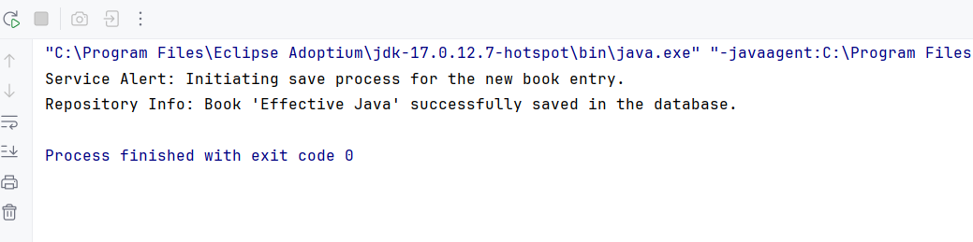

**Exercise 4: Creating and Configuring a Maven Project**

**pom.xml**

<project xmlns="http://maven.apache.org/POM/4.0.0"

xmlns:xsi="http://www.w3.org/2001/XMLSchema-instance"

xsi:schemaLocation="http://maven.apache.org/POM/4.0.0

http://maven.apache.org/xsd/maven-4.0.0.xsd">

<modelVersion>4.0.0</modelVersion>

<groupId>com.library</groupId>

<artifactId>LibraryManagement</artifactId>

<version>1.0-SNAPSHOT</version>

<properties>

<java.version>1.8</java.version>

<spring.version>5.3.34</spring.version>

<servlet.version>4.0.1</servlet.version>

</properties>

<dependencies>

<dependency>

<groupId>org.springframework</groupId>

<artifactId>spring-context</artifactId>

<version>${spring.version}</version>

</dependency>

<dependency>

<groupId>org.springframework</groupId>

<artifactId>spring-aop</artifactId>

<version>${spring.version}</version>

</dependency>

<dependency>

<groupId>org.springframework</groupId>

<artifactId>spring-webmvc</artifactId>

<version>${spring.version}</version>

</dependency>

<dependency>

<groupId>javax.servlet</groupId>

<artifactId>javax.servlet-api</artifactId>

<version>${servlet.version}</version>

<scope>provided</scope>

</dependency>

</dependencies>

<build>

<pluginManagement>

<plugins>

<plugin>

<groupId>org.apache.maven.plugins</groupId>

<artifactId>maven-compiler-plugin</artifactId>

<version>3.10.1</version>

<configuration>

<source>${java.version}</source>

<target>${java.version}</target>

</configuration>

</plugin>

</plugins>

</pluginManagement>

</build>

</project>

**Exercise 5: Configuring the Spring IoC Container**

**applicationContext.xml**

<?xml version="1.0" encoding="UTF-8"?>

<beans xmlns="http://www.springframework.org/schema/beans"

xmlns:xsi="http://www.w3.org/2001/XMLSchema-instance"

xsi:schemaLocation="

http://www.springframework.org/schema/beans

http://www.springframework.org/schema/beans/spring-beans.xsd">

<bean id="bookRepository" class="org.library.repository.BookRepository"/>

<bean id="bookService" class="org.library.service.BookService">

<property name="bookRepository" ref="bookRepository"/>

</bean>

</beans>

**BookRepository.java**

package org.library.repository;

public class BookRepository {

public void saveBook(String title) {

System.out.println("Repository Log: Book '" + title + "' has been recorded successfully.");

}

}

**BookService.java**

package org.library.service;

import org.library.repository.BookRepository;

public class BookService {

private BookRepository bookRepository;

public void setBookRepository(BookRepository bookRepository) {

this.bookRepository = bookRepository;

}

public void addBook(String title) {

System.out.println("Service Notice: Processing request to add a book...");

bookRepository.saveBook(title);

}

}

**Main.java**

package org.library;

import org.library.service.BookService;

import org.springframework.context.ApplicationContext;

import org.springframework.context.support.ClassPathXmlApplicationContext;

public class Main {

public static void main(String[] args) {

ApplicationContext context = new ClassPathXmlApplicationContext("applicationContext.xml");

BookService bookService = (BookService) context.getBean("bookService");

bookService.addBook("Clean Code");

}

}

**Output :**

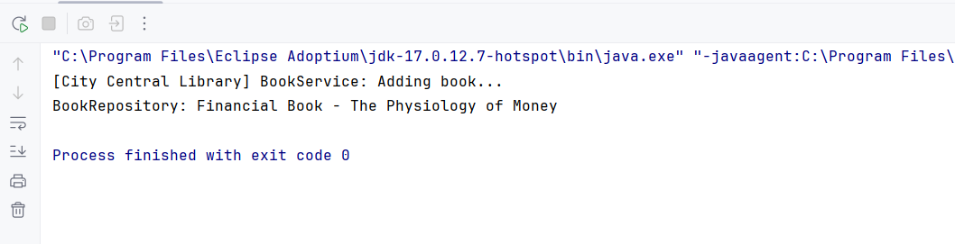

**Exercise 7: Implementing Constructor and Setter Injection**

**resources/applicationContext.xml**

<?xml version="1.0" encoding="UTF-8"?>

<beans xmlns="http://www.springframework.org/schema/beans"

xmlns:xsi="http://www.w3.org/2001/XMLSchema-instance"

xsi:schemaLocation="http://www.springframework.org/schema/beans

http://www.springframework.org/schema/beans/spring-beans.xsd">

<bean id="bookRepository" class="org.library.repository.BookRepository"/>

<bean id="bookService" class="org.library.service.BookService">

<constructor-arg ref="bookRepository"/>

<property name="libraryName" value="Central Knowledge Hub"/>

</bean>

</beans>

**BookService.java**

package org.library.service;

import org.library.repository.BookRepository;

public class BookService {

private BookRepository repo;

private String libraryName;

public BookService(BookRepository repo) {

this.repo = repo;

}

public void setLibraryName(String libraryName) {

this.libraryName = libraryName;

}

public void registerBook(String bookTitle) {

System.out.println("Library [" + libraryName + "] is registering a new book...");

repo.saveBook(bookTitle);

}

}

**BookRepository.java**

package org.library.repository;

public class BookRepository {

public void saveBook(String title) {

System.*out*.println("BookRepository: Financial Book - " + title);

}

}

**Main.java**

package org.library;

import org.library.service.BookService;

import org.springframework.context.ApplicationContext;

import org.springframework.context.support.ClassPathXmlApplicationContext;

public class Main {

public static void main(String[] args) {

ApplicationContext context = new ClassPathXmlApplicationContext("applicationContext.xml");

BookService service = (BookService) context.getBean("bookService");

service.registerBook("The Physiology of Money");

}

}

**Output :**

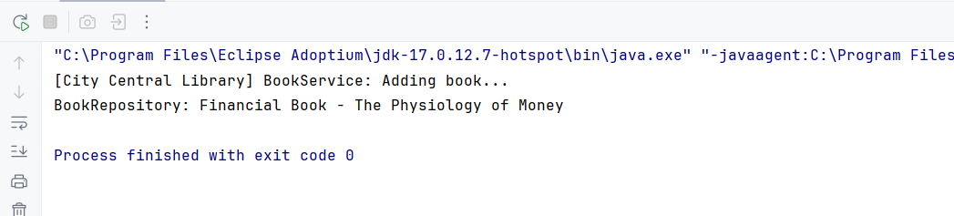

**Exercise 9: Creating a Spring Boot Application**

**BookController.java:**

package com.example.library.controller;  
  
import com.example.library.entity.Book;  
import com.example.library.repository.BookRepository;  
import org.springframework.beans.factory.annotation.Autowired;  
import org.springframework.web.bind.annotation.*;  
  
import java.util.List;  
import java.util.Optional;  
  
@RestController  
@RequestMapping("/api/books")  
public class BookController {  
  
 @Autowired  
 private BookRepository bookRepository;  
  
 @GetMapping  
 public List<Book> getAllBooks() {  
 return bookRepository.findAll();  
 }  
  
 @GetMapping("/{id}")  
 public Optional<Book> getBookById(@PathVariable Long id) {  
 return bookRepository.findById(id);  
 }  
  
 @PostMapping  
 public Book addBook(@RequestBody Book book) {  
 return bookRepository.save(book);  
 }  
  
 @PutMapping("/{id}")  
 public Book updateBook(@PathVariable Long id, @RequestBody Book bookDetails) {  
 Book book = bookRepository.findById(id).orElseThrow();  
 book.setTitle(bookDetails.getTitle());  
 book.setAuthor(bookDetails.getAuthor());  
 book.setCategory(bookDetails.getCategory());  
 return bookRepository.save(book);  
 }  
  
 @DeleteMapping("/{id}")  
 public void deleteBook(@PathVariable Long id) {  
 bookRepository.deleteById(id);  
 }  
}

**Book.java:**

package com.example.library.entity;  
  
import jakarta.persistence.*;  
  
@Entity  
public class Book {  
  
 @Id  
 @GeneratedValue(strategy = GenerationType.*IDENTITY*)  
 private Long id;  
  
 private String title;  
 private String author;  
 private String category;  
  
 public Book() {}  
  
 public Book(String title, String author, String category) {  
 this.title = title;  
 this.author = author;  
 this.category = category;  
 }  
  
 // Getters and setters  
  
 public Long getId() {  
 return id;  
 }  
  
 public String getTitle() {  
 return title;  
 }  
  
 public void setTitle(String title) {  
 this.title = title;  
 }  
  
 public String getAuthor() {  
 return author;  
 }  
  
 public void setAuthor(String author) {  
 this.author = author;  
 }  
  
 public String getCategory() {  
 return category;  
 }  
  
 public void setCategory(String category) {  
 this.category = category;  
 }  
}

**LibraryManagementApplication.java:**

package com.example.library;  
  
import org.springframework.boot.SpringApplication;  
import org.springframework.boot.autoconfigure.SpringBootApplication;  
  
@SpringBootApplication  
public class LibraryManagementApplication {  
 public static void main(String[] args) {  
 SpringApplication.*run*(LibraryManagementApplication.class, args);  
 }  
}

**Application.properties:**

# H2 In-memory Database  
spring.datasource.url=jdbc:h2:mem:librarydb  
spring.datasource.driverClassName=org.h2.Driver  
spring.datasource.username=sa  
spring.datasource.password=  
spring.jpa.database-platform=org.hibernate.dialect.H2Dialect  
  
# Enable H2 Console  
spring.h2.console.enabled=true  
spring.h2.console.path=/h2-console  
  
# Show SQL  
spring.jpa.show-sql=true  
spring.jpa.hibernate.ddl-auto=update

